|  |  |
| --- | --- |
| **Hadoop 1.x** | **Hadoop 2.x** |
| Single Name Node (Single point of failure) | Active and standby Name Node , high availability can be configured |
| **Job Tracker** ( keep tracking of job, scheduling job ,keep history of job, health of task tracker, too much overloaded)  Single point of failure | **Resource Manager** (scheduler, Applications Manager) ( identify the available resources, negotiation of resources)  **Application master** ( manage life cycle of job)  **Timeline server** ( history of job)  Performance is higher than mapred1  High Availability can be configured for Resource Manager |
| **Task Tracker** (run on each data node or slave machine) | **Node Manager** act as a slave for Resource Manager Each Node Manager tracks the available data processing resources on its slave node and sends regular reports to the Resource Manager.  (responsible for create execution **containers**, monitoring their resource usage (CPU, memory, disk, network) and reporting the same to the ResourceManager)  A **container** is a collection of all the resources necessary to run an application: CPU cores, memory, network bandwidth, and disk space |

**Application master** is responsible for negotiating resources from the ResourceManager and working with the NodeManager(s) to execute and monitor the containers and their resource consumption. It has the responsibility of negotiating appropriate resource containers from the ResourceManager, tracking their status and monitoring progress

The **ResourceManager** has two main components: **Scheduler** and **ApplicationsManager**.

**The Scheduler is responsible for allocating resources** to the various running applications subject to familiar constraints of capacities, queues etc. The Scheduler is pure scheduler in the sense that it performs no monitoring or tracking of status for the application. Also, it offers no guarantees about restarting failed tasks either due to application failure or hardware failures. The Scheduler performs its scheduling function based the resource requirements of the applications; it does so based on the abstract notion of a resource *Container* which incorporates elements such as memory, cpu, disk, network etc.

The Scheduler has a pluggable policy which is responsible for partitioning the cluster resources among the various queues, applications etc. The current schedulers such as the [CapacityScheduler](http://hadoop.apache.org/docs/current/hadoop-yarn/hadoop-yarn-site/CapacityScheduler.html) and the [FairScheduler](http://hadoop.apache.org/docs/current/hadoop-yarn/hadoop-yarn-site/FairScheduler.html) would be some examples of plug-ins.

**The ApplicationsManager is responsible for accepting job-submissions, negotiating the first container for executing the application specific ApplicationMaster and provides the service for restarting the ApplicationMaster container on failure**. Manages the Application

The per-application **ApplicationMaster** has the responsibility of negotiating appropriate resource containers from the Scheduler, tracking their status and monitoring for progress.

**The NodeManager is the per-machine slave, which is responsible for launching the applications’ containers, monitoring their resource usage (cpu, memory, disk, network) and reporting the same to the ResourceManager.**

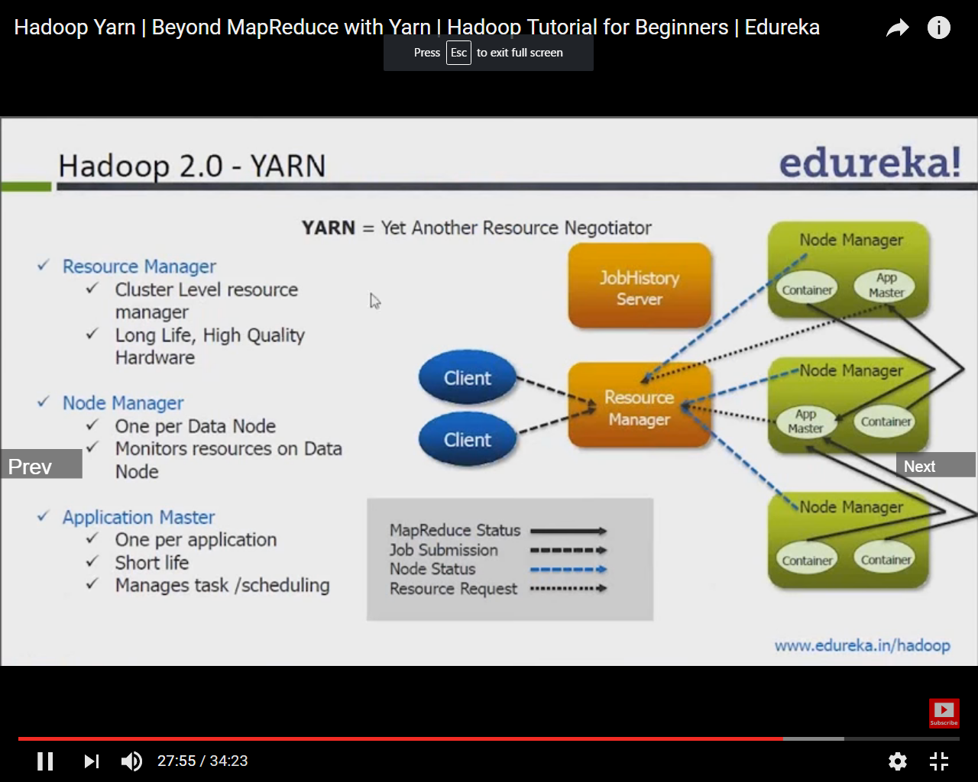

In YARN, there are at least three actors:

* the **Job Submitter** (the client)
* the **Resource Manager** (the master)
* the **Node Manager** (the slave)

The application startup process is the following:

1. a client submits an application to the Resource Manager
2. the Resource Manager allocates a container
3. the Resource Manager contacts the related Node Manager
4. the Node Manager launches the container
5. the Container executes the **Application Master**

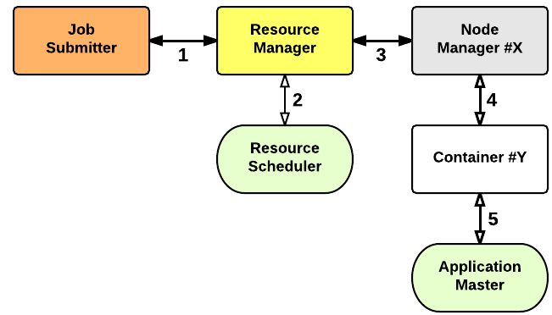

The Application Master is responsible for the execution of a single application. It asks for containers to the Resource Scheduler (Resource Manager) and executes specific programs (e.g., the main of a Java class) on the obtained containers. The Application Master knows the application logic and thus it is framework-specific. The MapReduce framework provides its own implementation of an Application Master.

The Resource Manager is a single point of failure in YARN. Using Application Masters, YARN is spreading over the cluster the metadata related to running applications. This reduces the load of the Resource Manager and makes it fast recoverable.

**Node Manager** manages the life cycle of containers, container resource monitoring

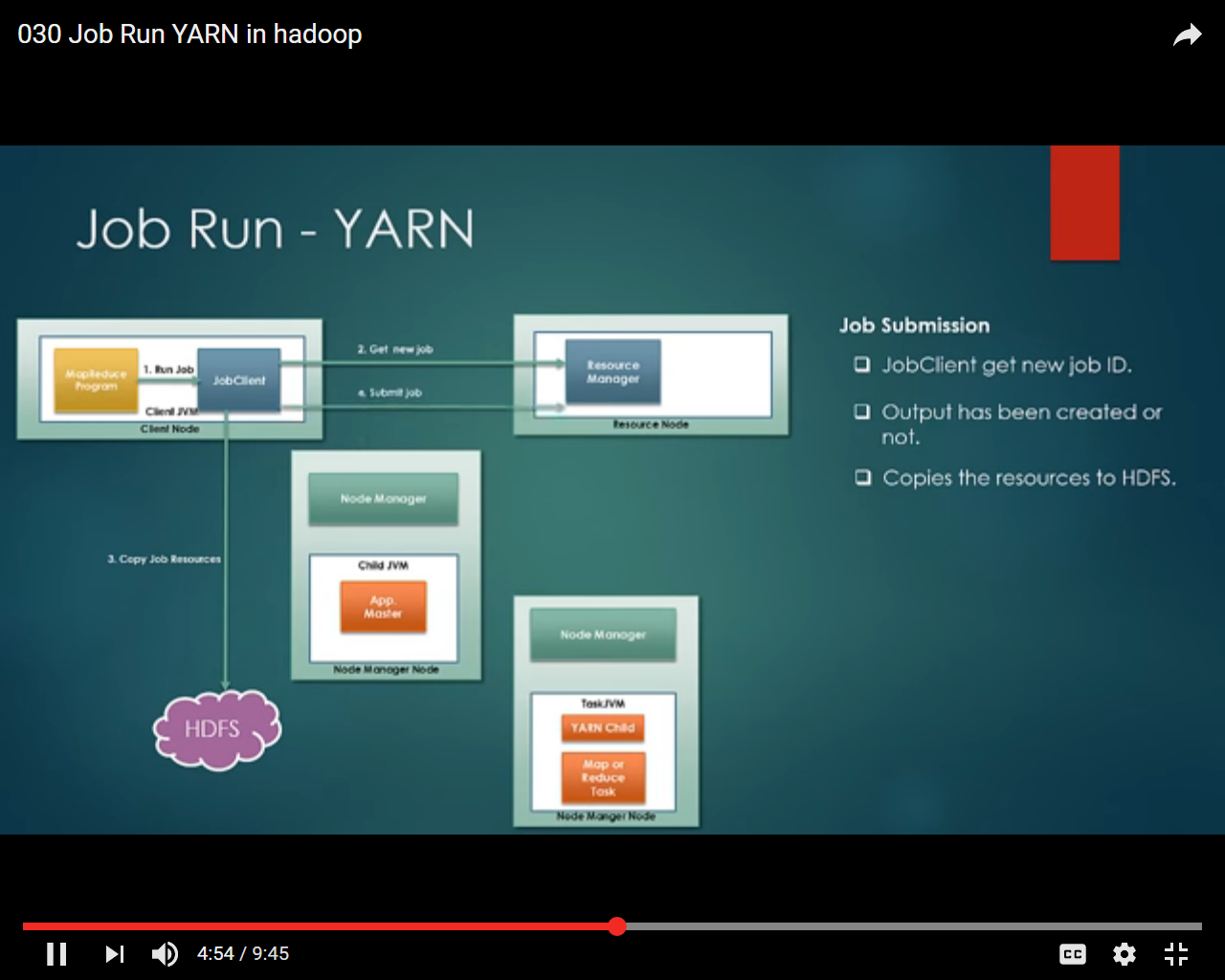

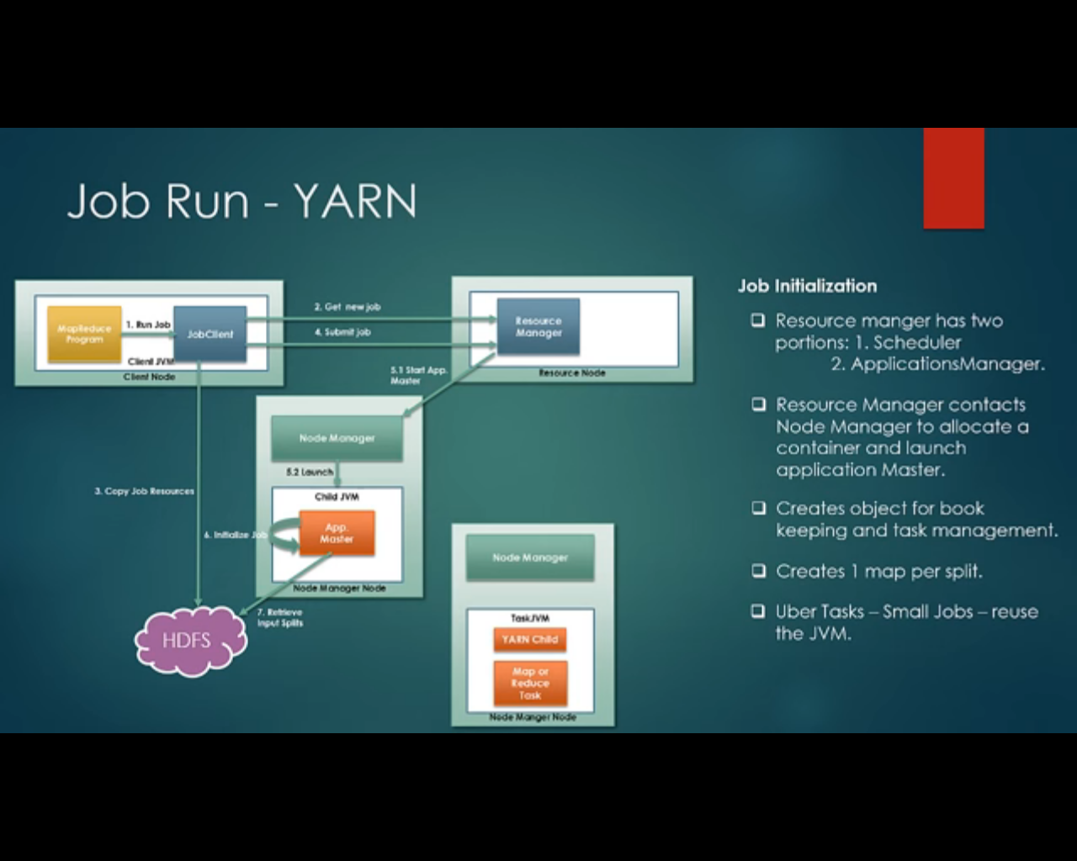

Uber tasks- when small jobs are assigned to single jvm instead of launching new container

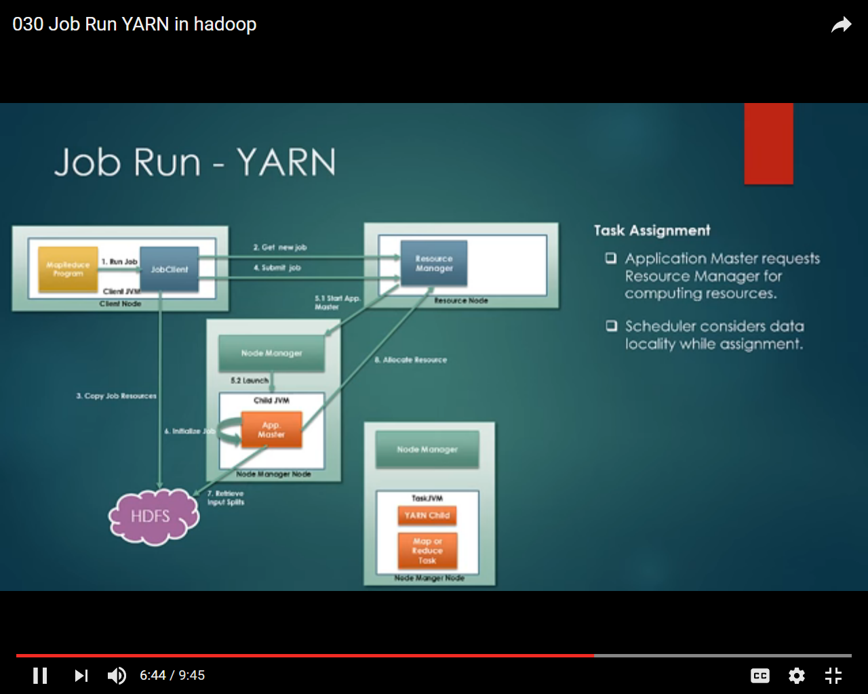

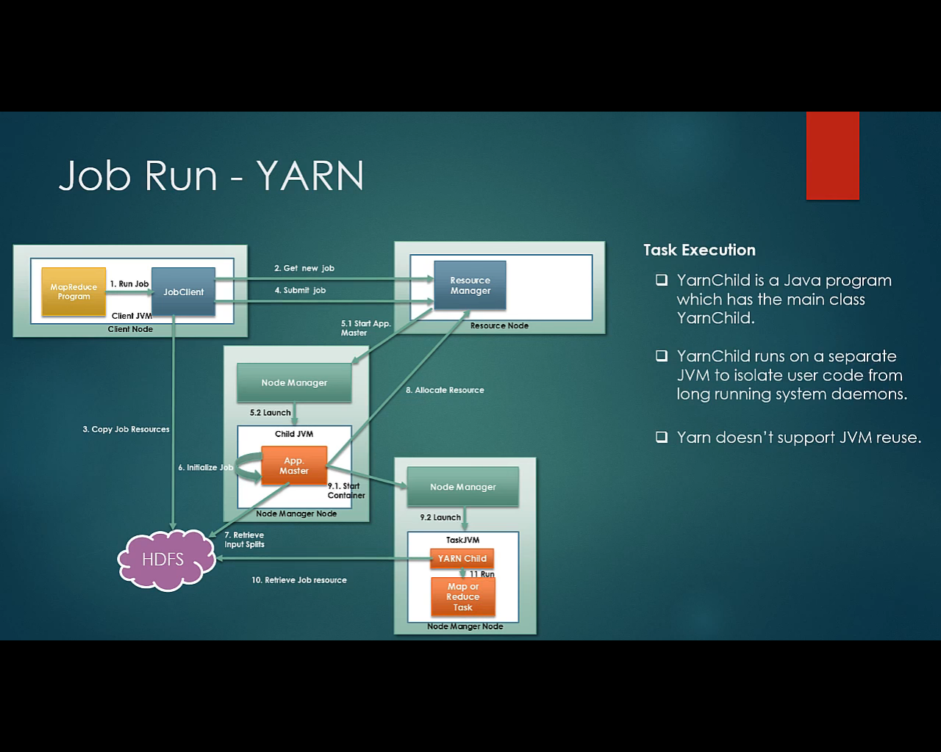

Progress phase

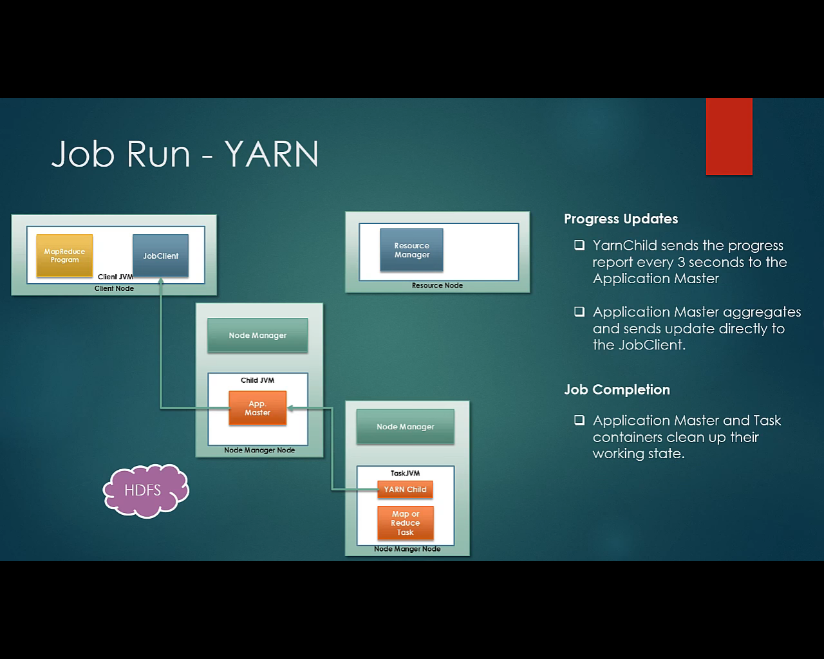

Failure scenario in YARN

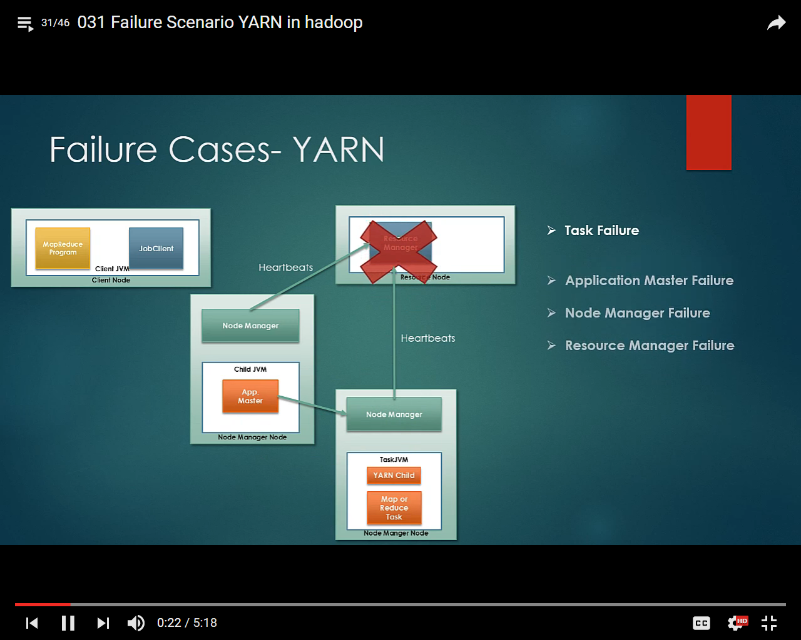

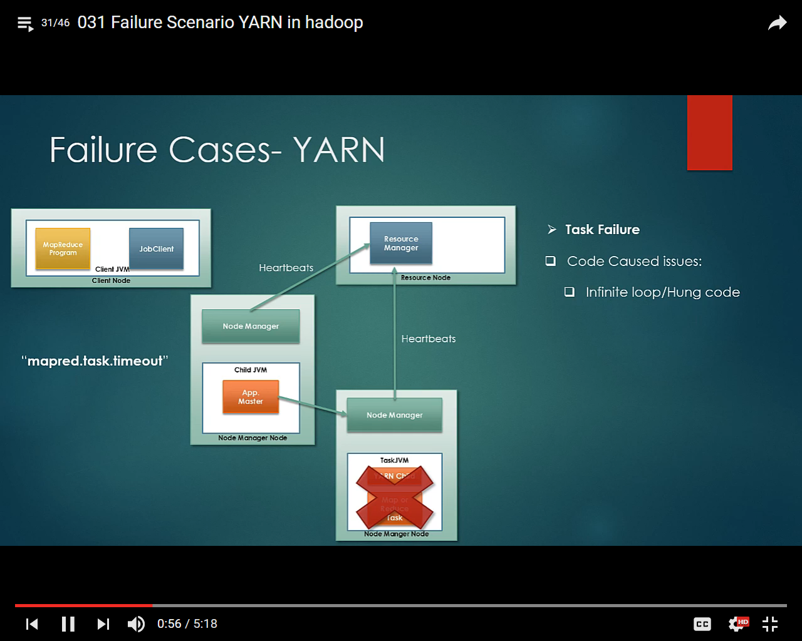

After timeout Task marked as failed

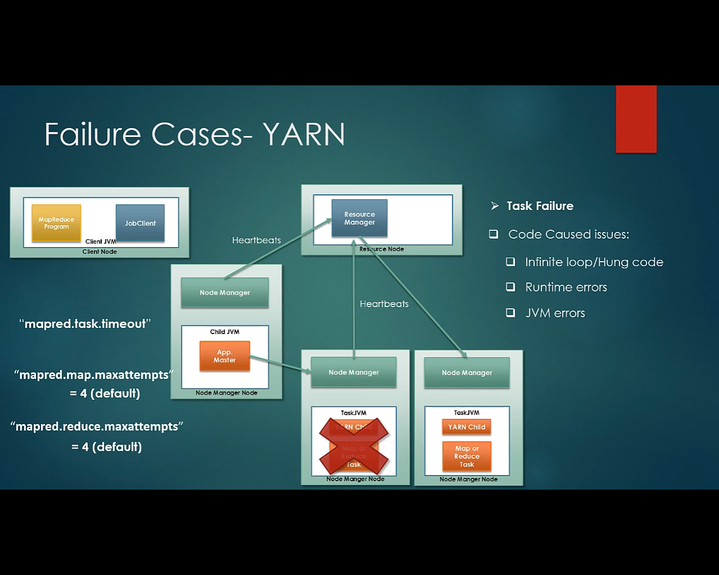

For runtime and jvm error, fail tasks attempted on another node, the number of maxattempts configured in map and reduces properties, after max attempt the complete job is marked as failed

Failure of some tasks is acceptable so failure of one and two job must not marked the completed job as a failure, for those cases we can define maxprecent properties

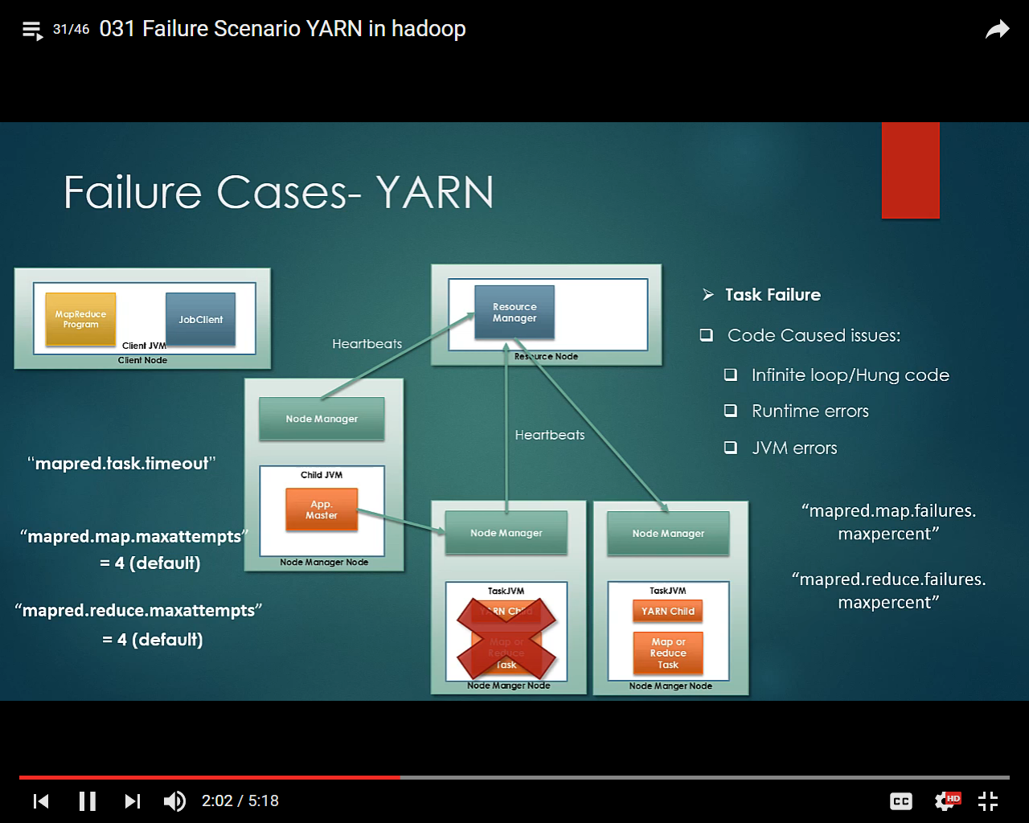

**App Master Failure**

if application master fails the task that have run under it need not be resubmitted ,they can be recovered but by default the recovery is not switched on, property **yarn.app.mapreduce.am.job.recovery.enable** would be needed to set as true

When app master fails resource manager stop getting heartbeat from the app master, RM recognize that app master has failed, RM start the app master on a new container, if the recovery option is set the status of task is recovered and execution of the job continue

Number of attempts can be configured in “yarn.resourcemanager.am.max-retries”

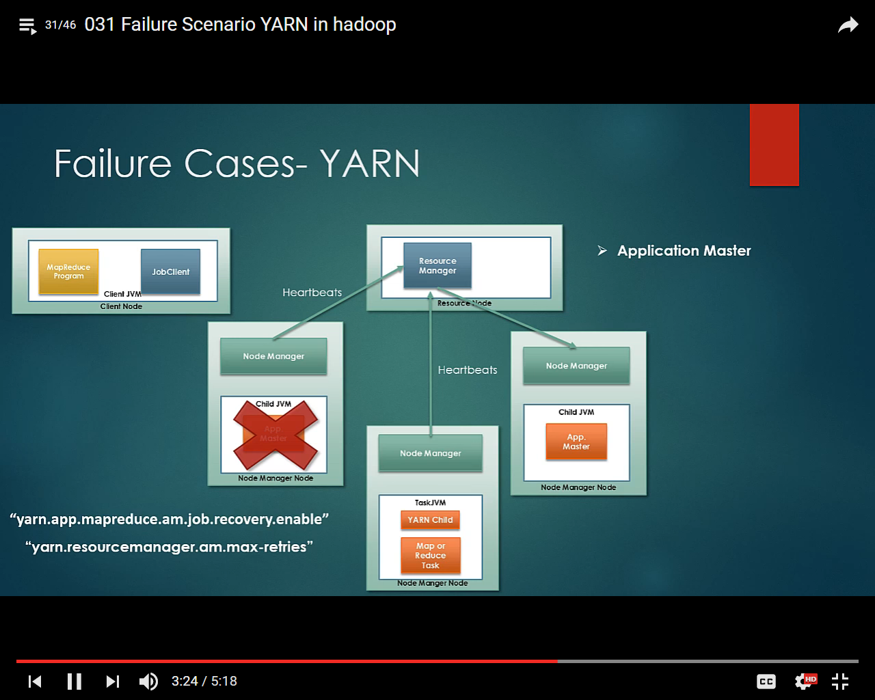

**Node Manager Fails**

If the NM fails it stops sending the heartbeats to RM, RM wait for the NM for a while considering the case it might have slow down if RM doesn’t receives heartbeats for certain period of time it assumes that NM has crashed , if AM is running under the failed NM the steps describing App master failures has followed, all the remaining tasks re spawn on new node manager, if tasks under a specific NM fails often and cross a threshold the node is taken off from the available pool and blacklisted(process to track the poorly performing nodes)

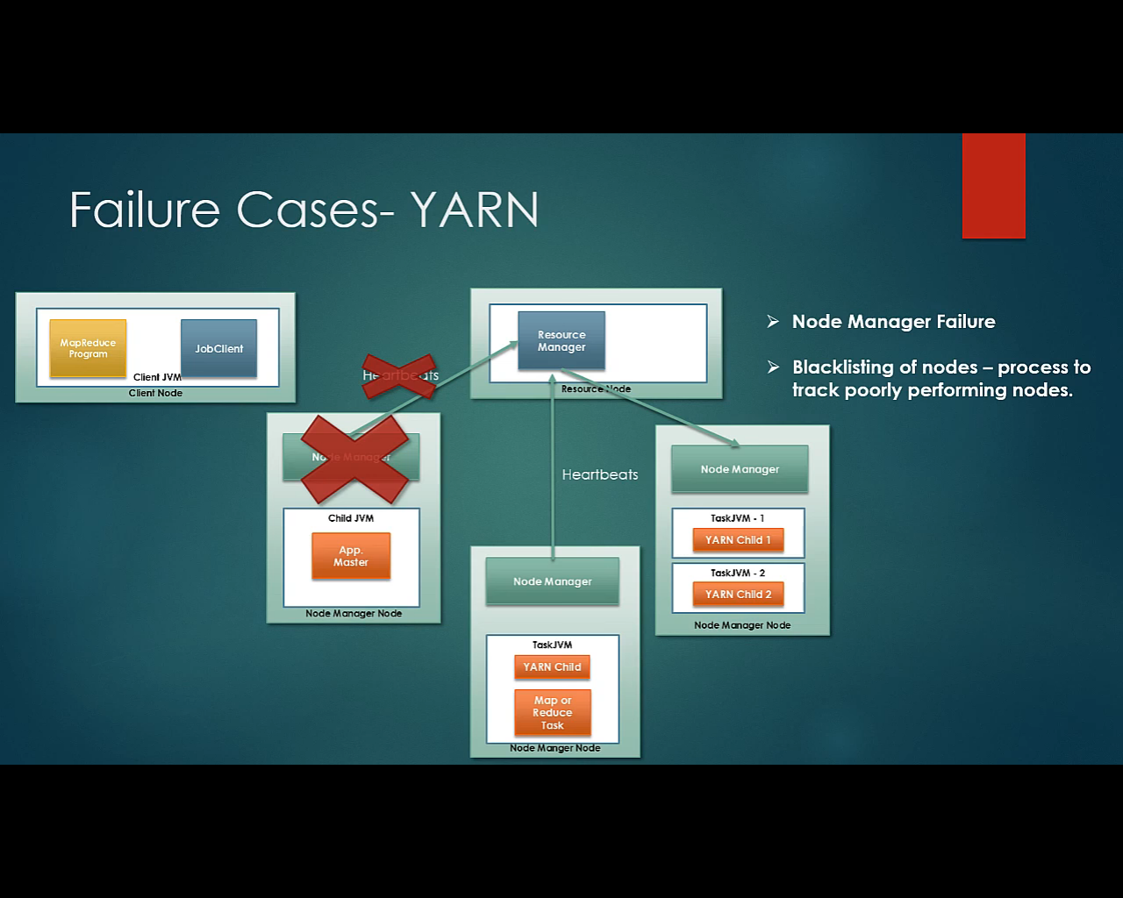

Resource Manager Failure

If RM fails neither the job nor the tasks container can be launched but in YARN checkpoint mechanism put in the place, after a crash new RM instance is brought up by the administrator (HA could be setup) and it recovers from the last save state so the reruns of all the jobs is not required

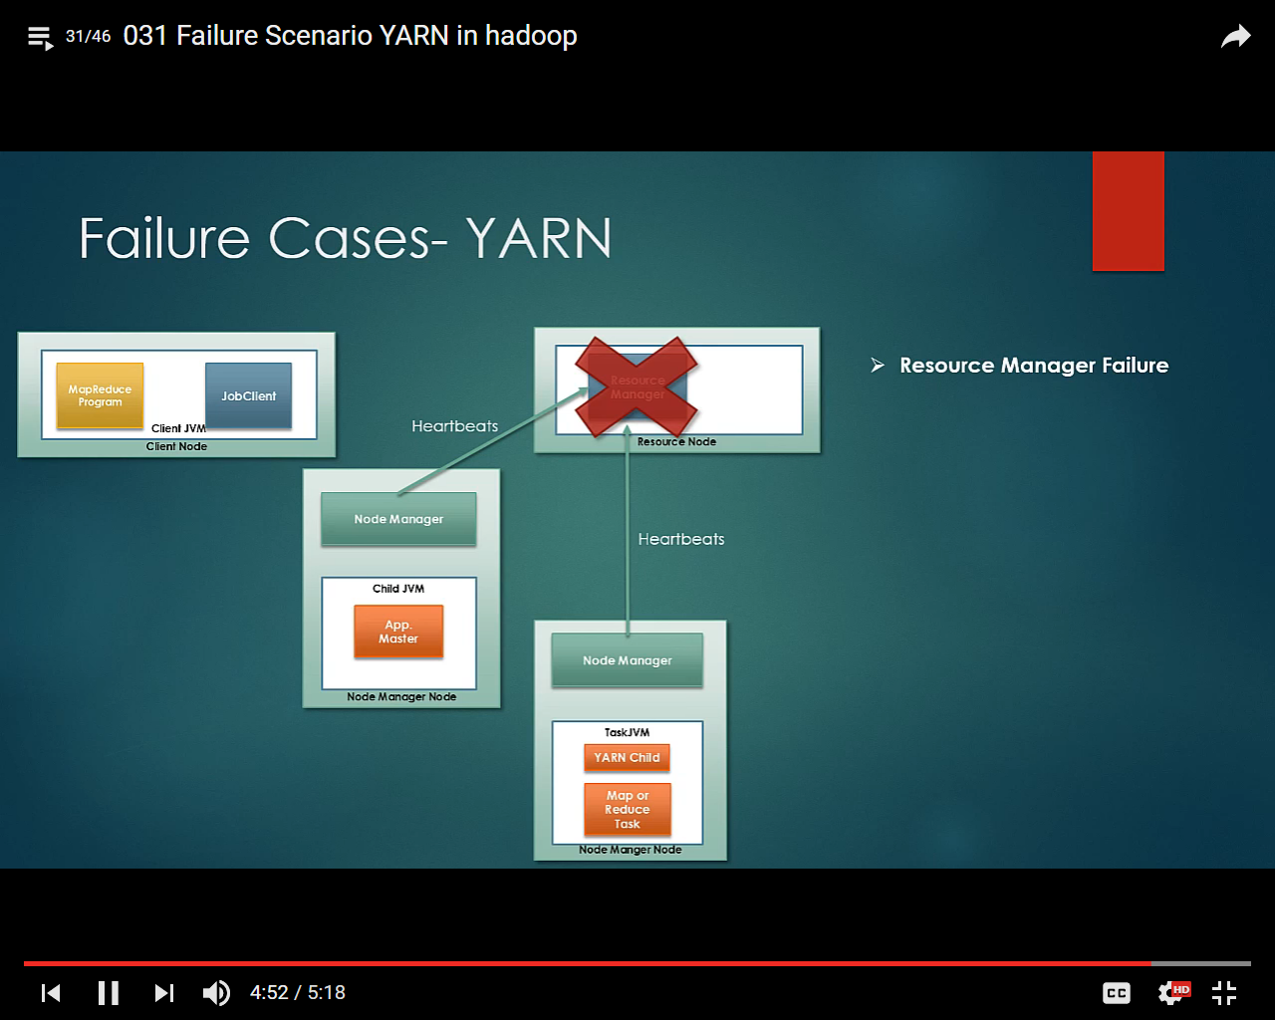

<https://www.youtube.com/watch?v=mIUd3pyD6Qc&list=PL67o_jNoqTwCYosJ62UMadl8NHPUhBM9X&index=32>

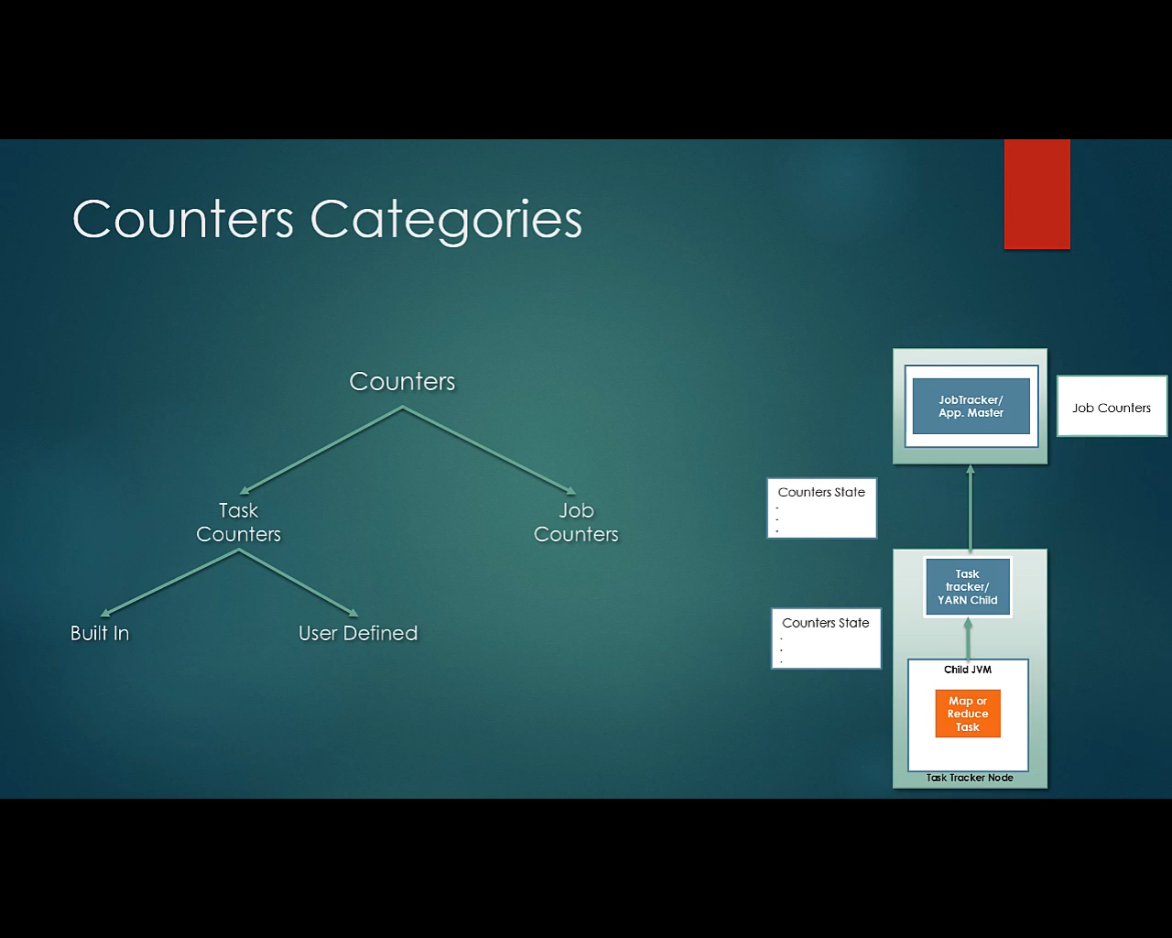

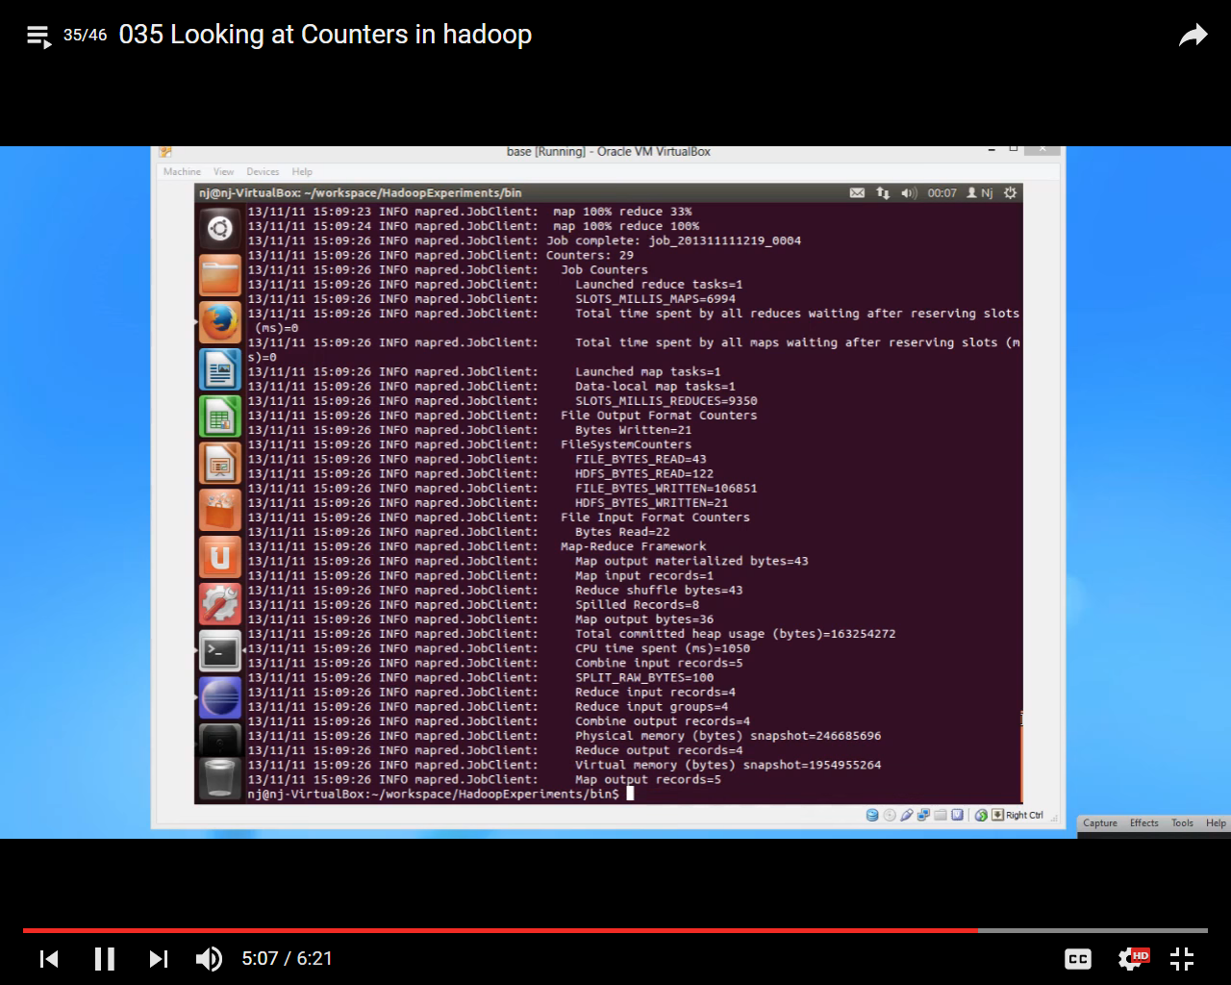

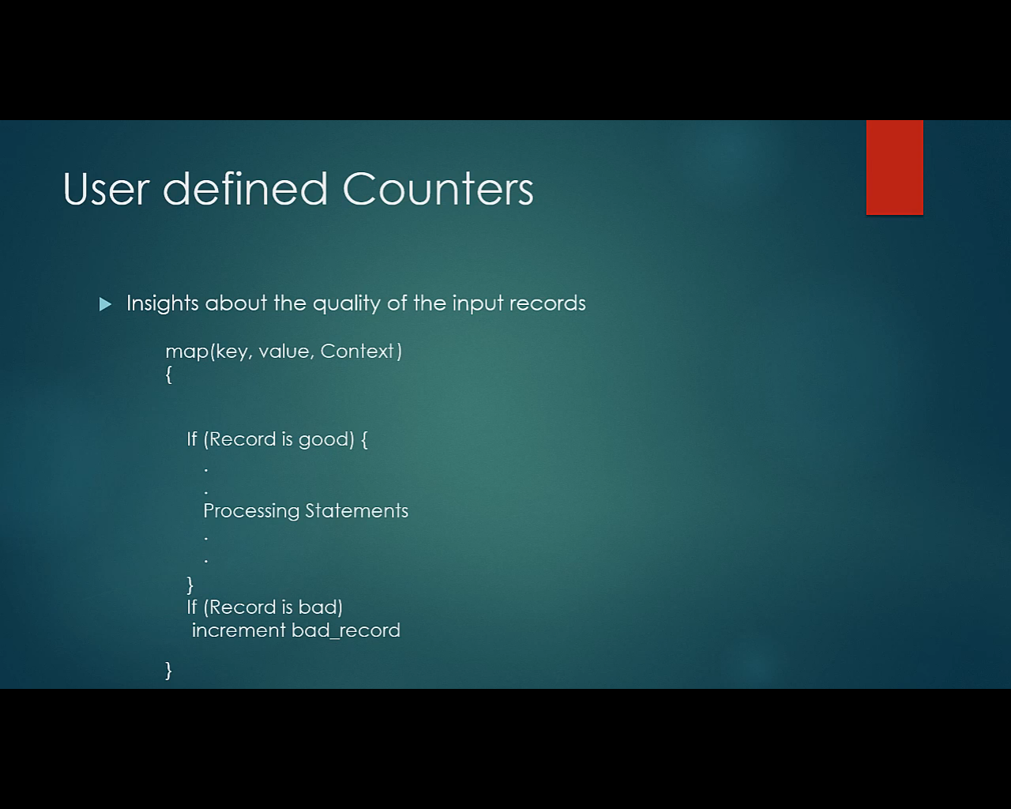

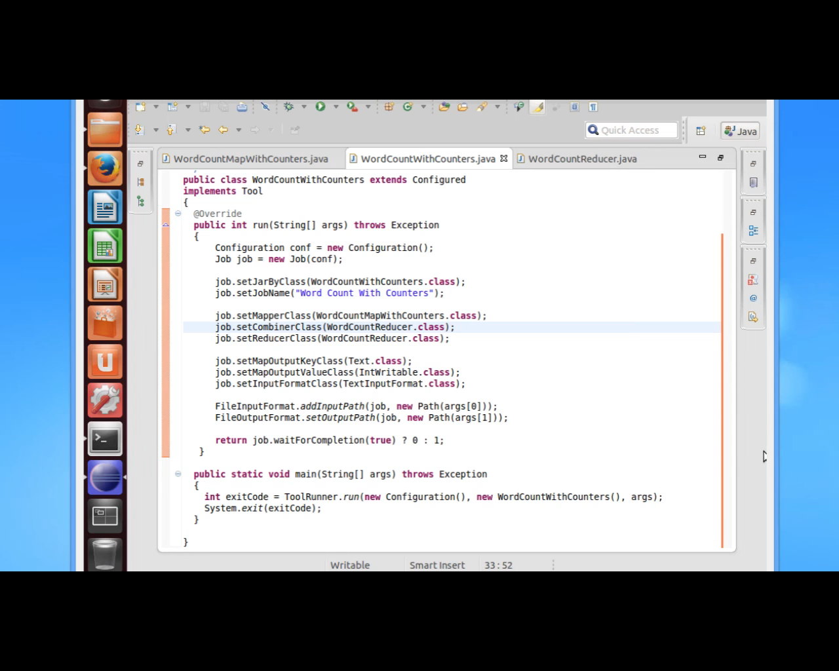

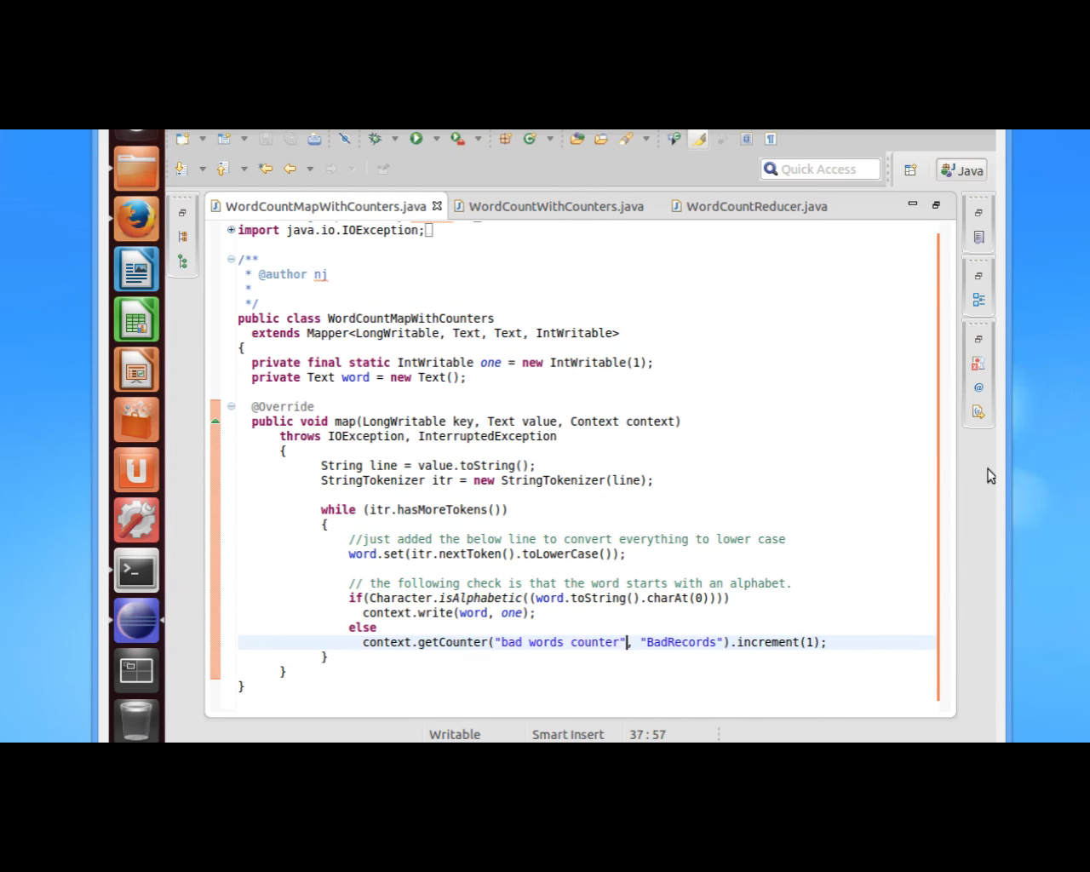

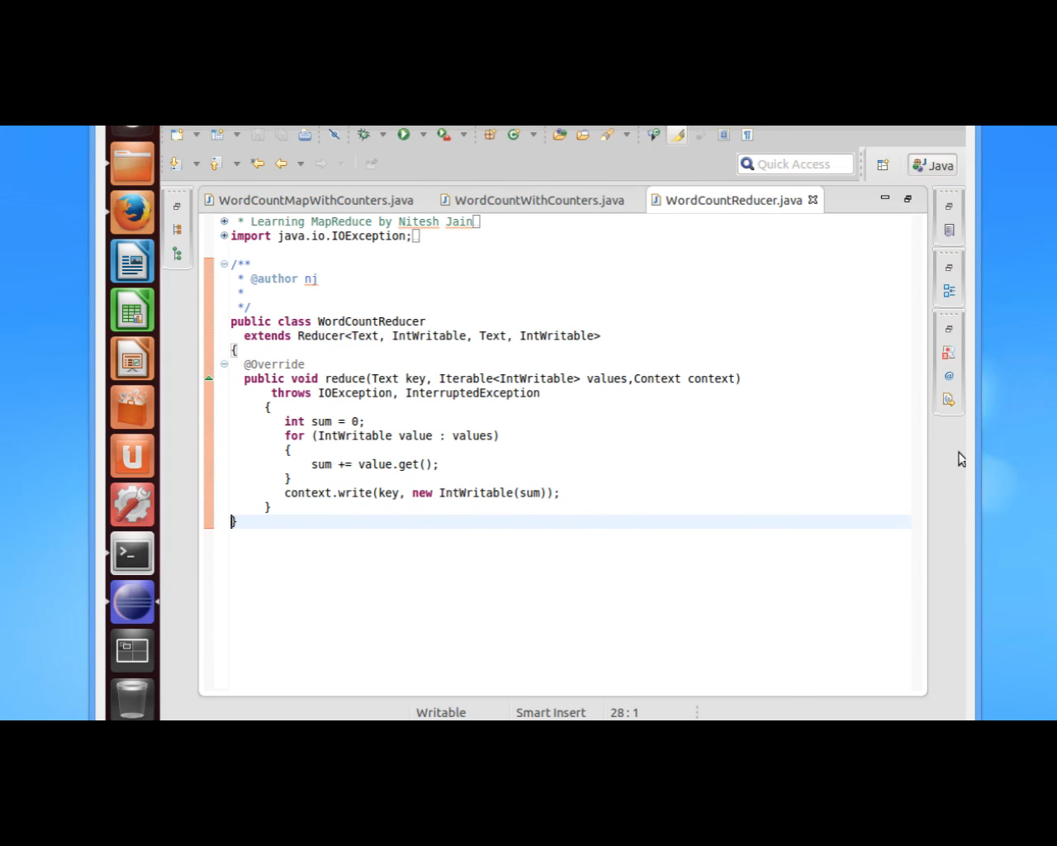

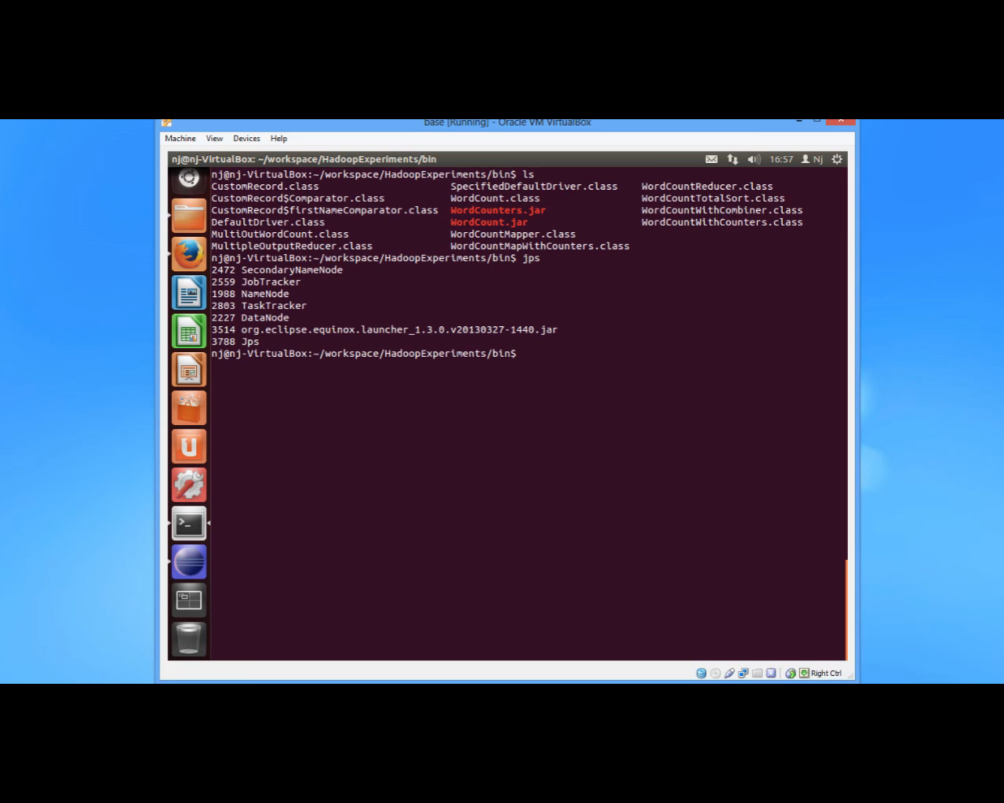

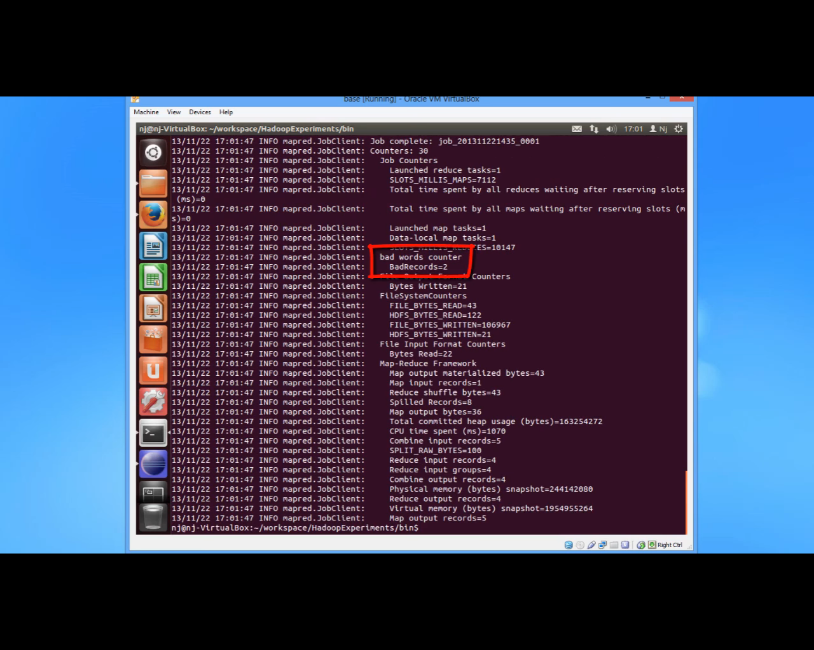

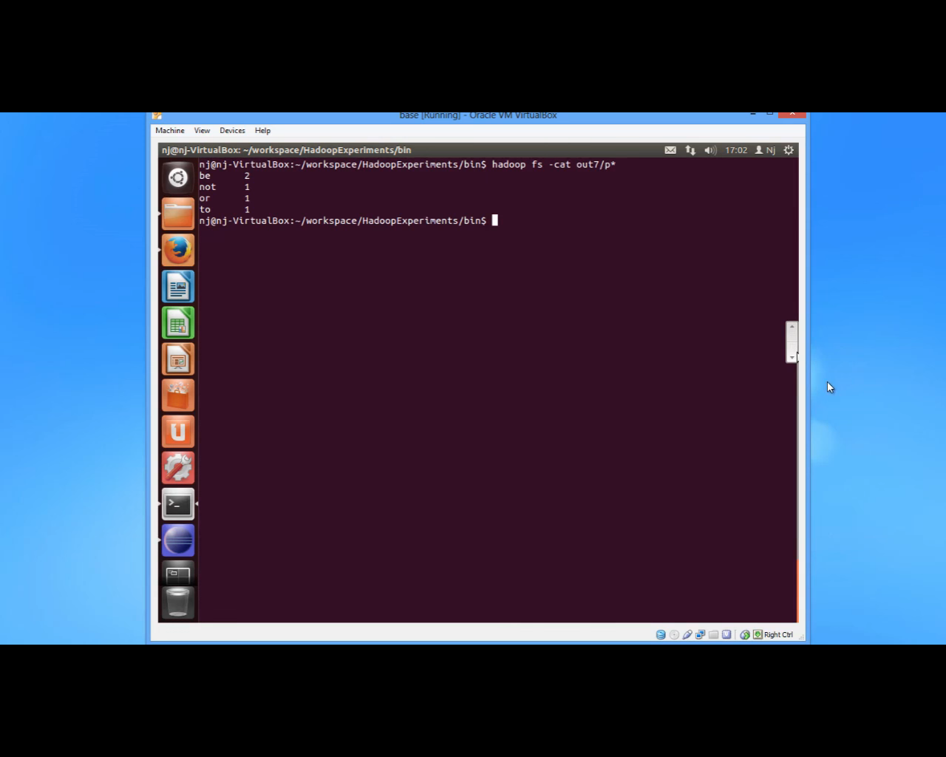

**Secondary Sort**

If we want to sort by a value not just by key

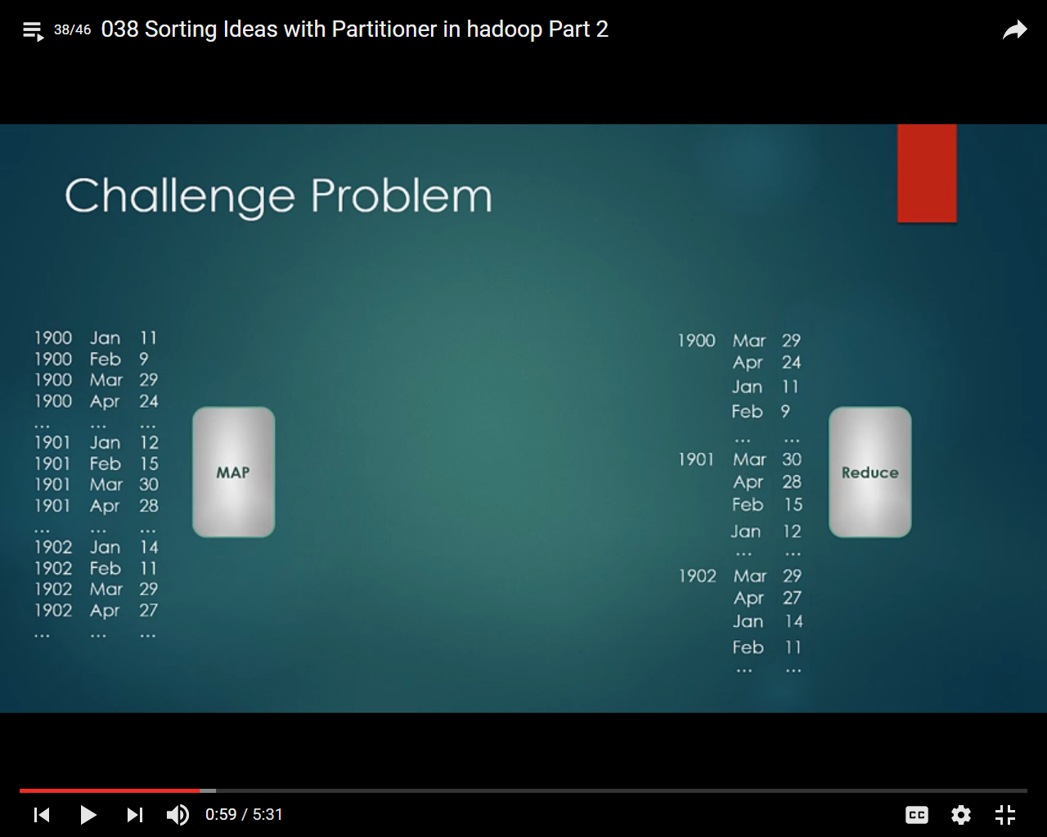

We have year month and max temperature; we want to sort it by temperature in descending order

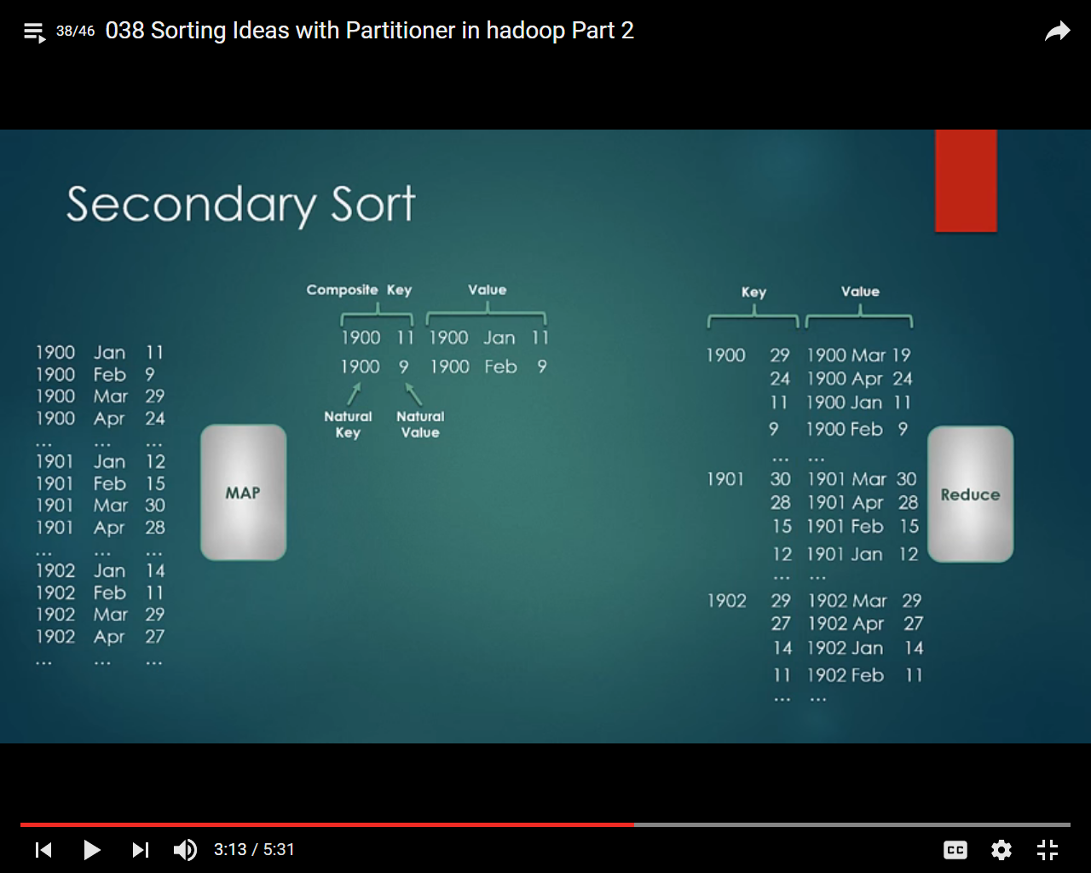

We can use composite key concept which composed of two portion- natural key and natural value

Natural key a portion of composite key which can be considered composing partition and grouping

Natural value is a portion of composite key which can be considered while sorting

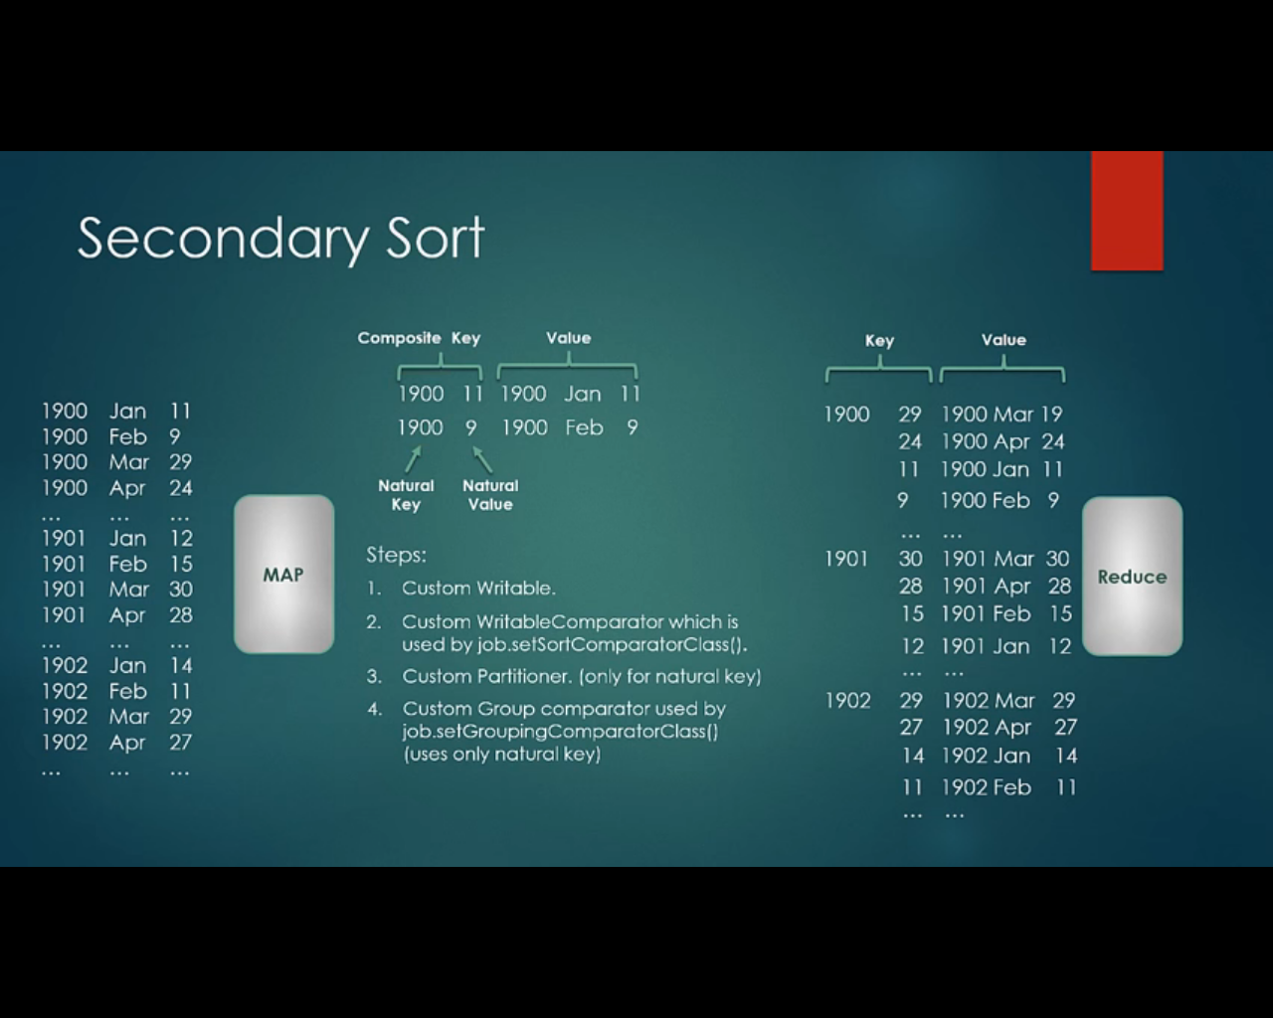

Map Side Join

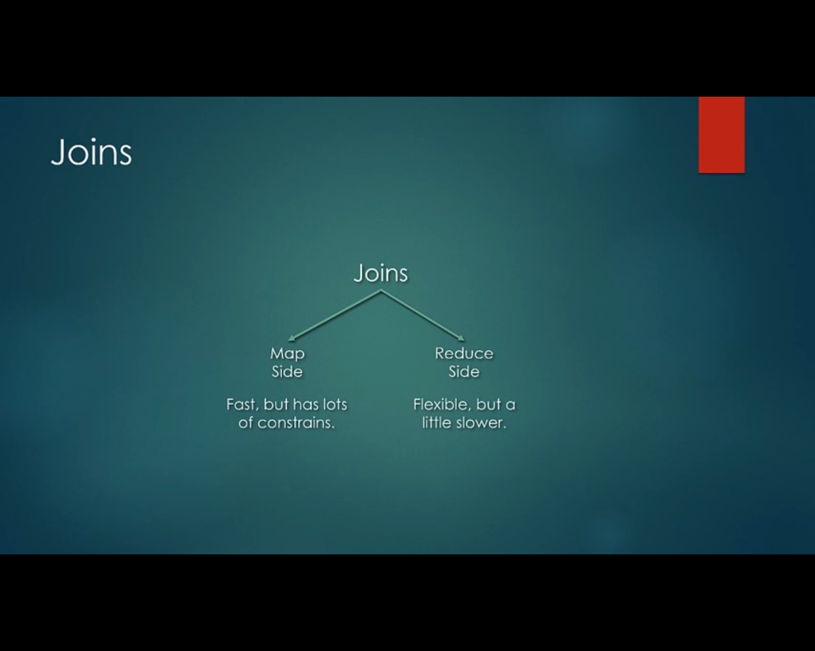

It is highly recommended to use pig or hive for join operation instead of writing code in java , though java solution will be optimized but it is very complex to write

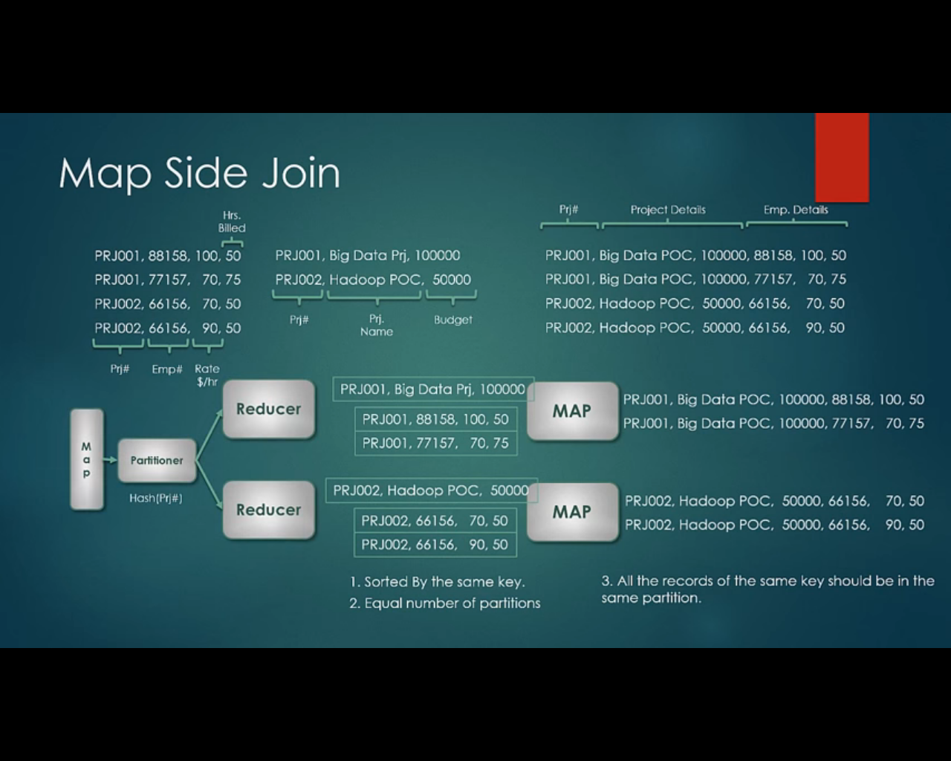

Reduce side join

We need to tag the different dataset with some unique value so that it can be identified and reduce side

We will have two different mapper classes to emit values

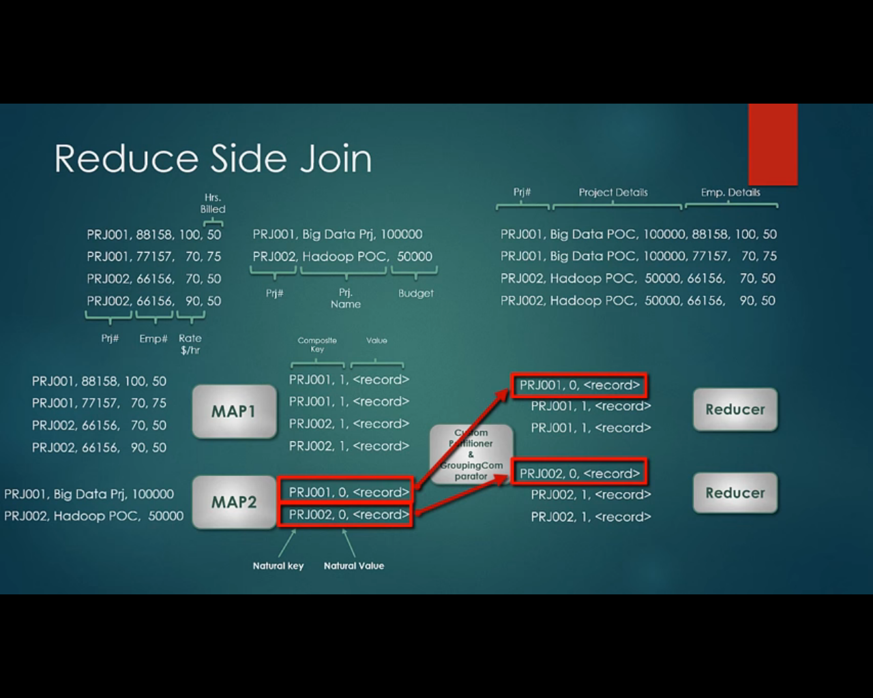

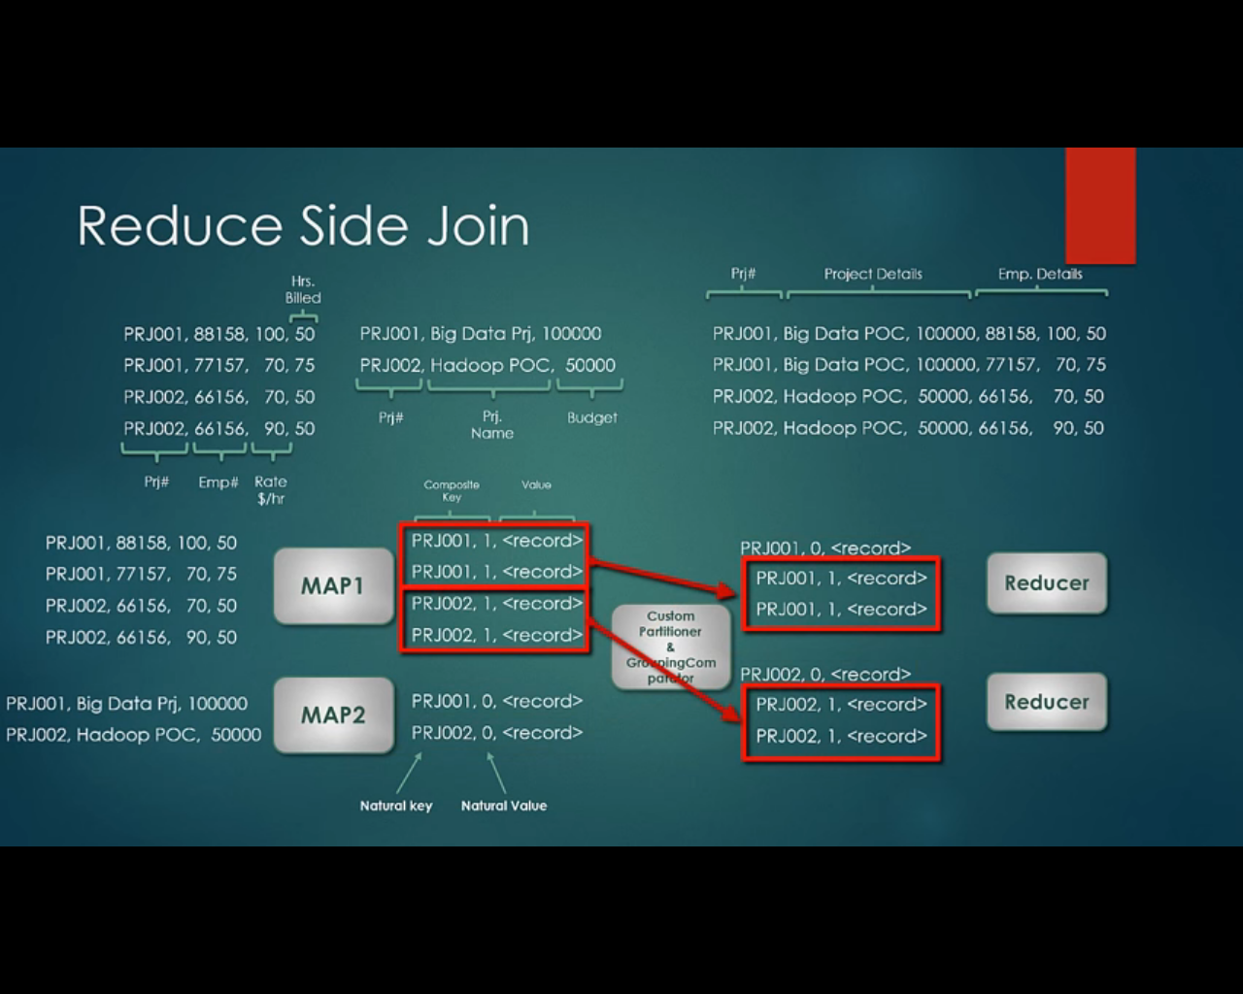

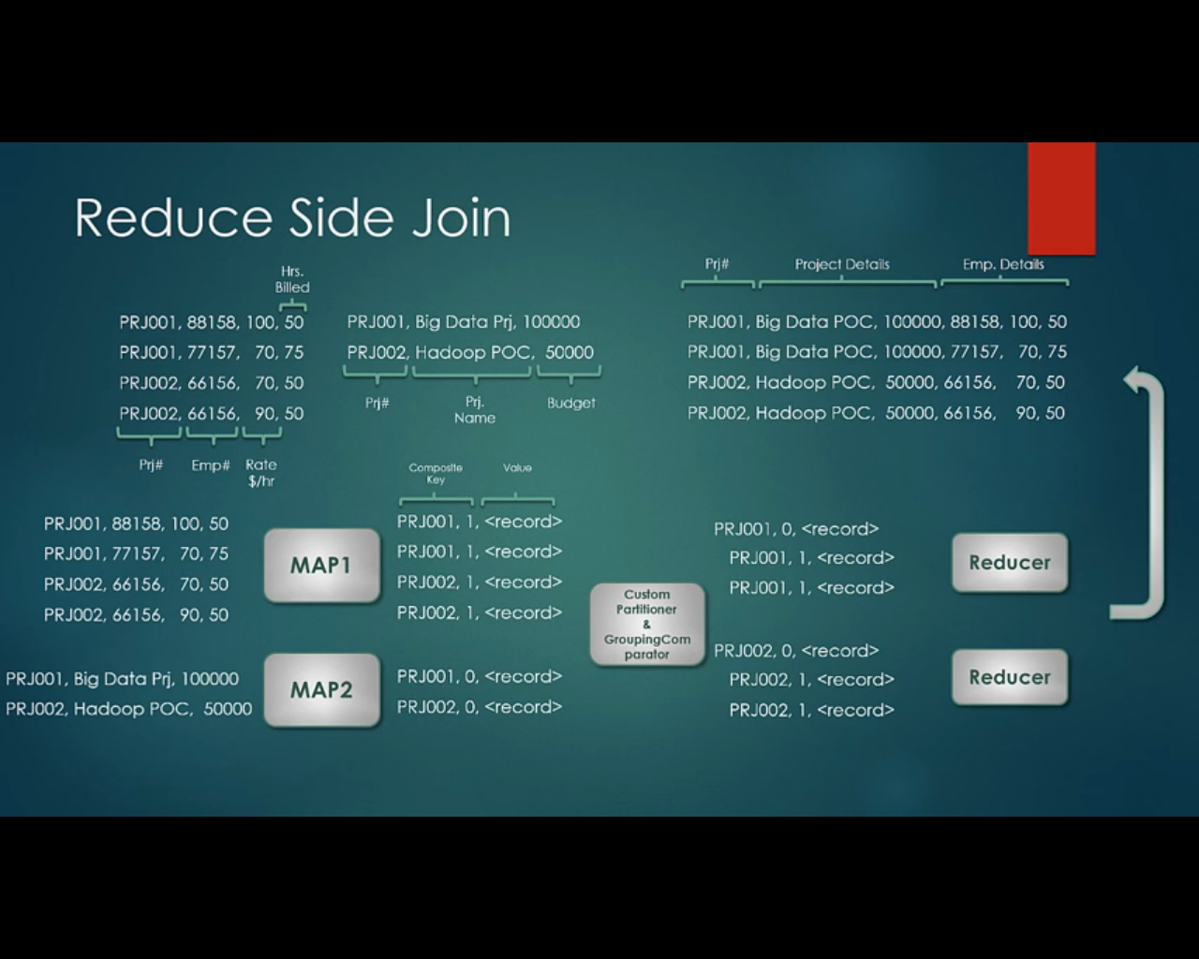

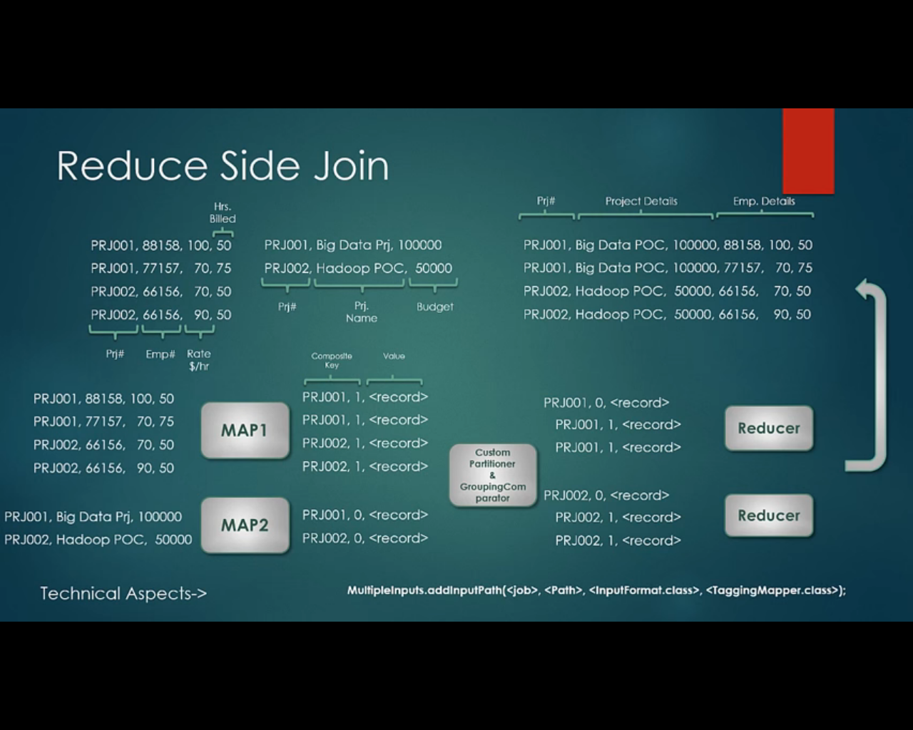we can use MultipleInputs objects

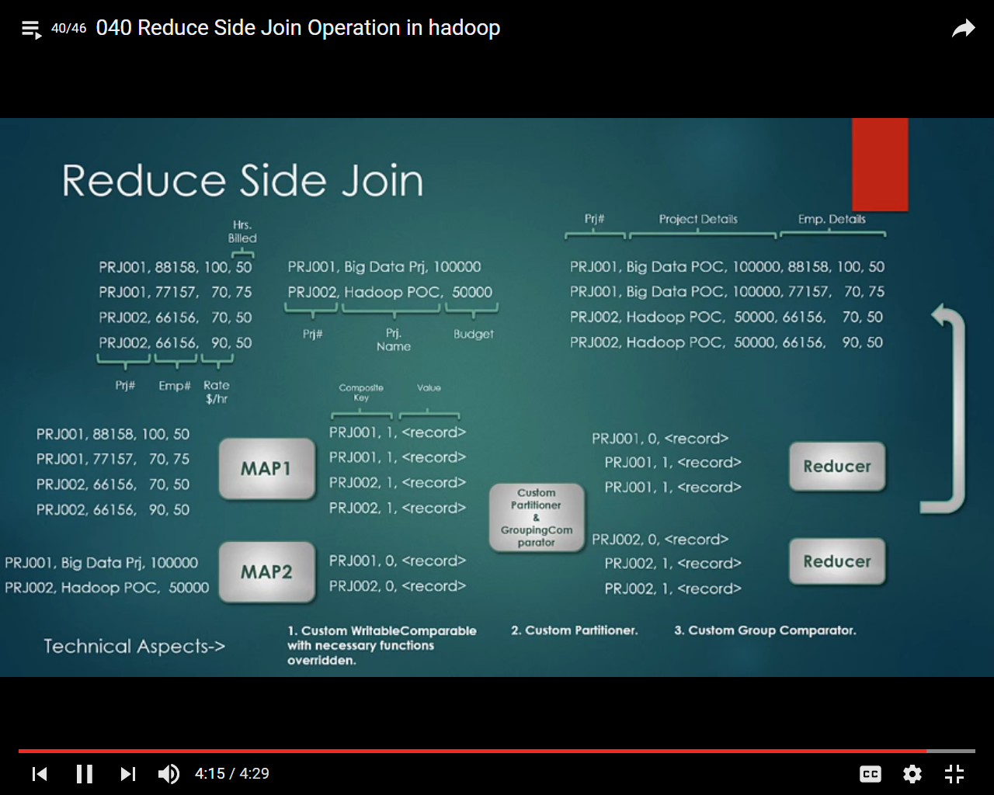

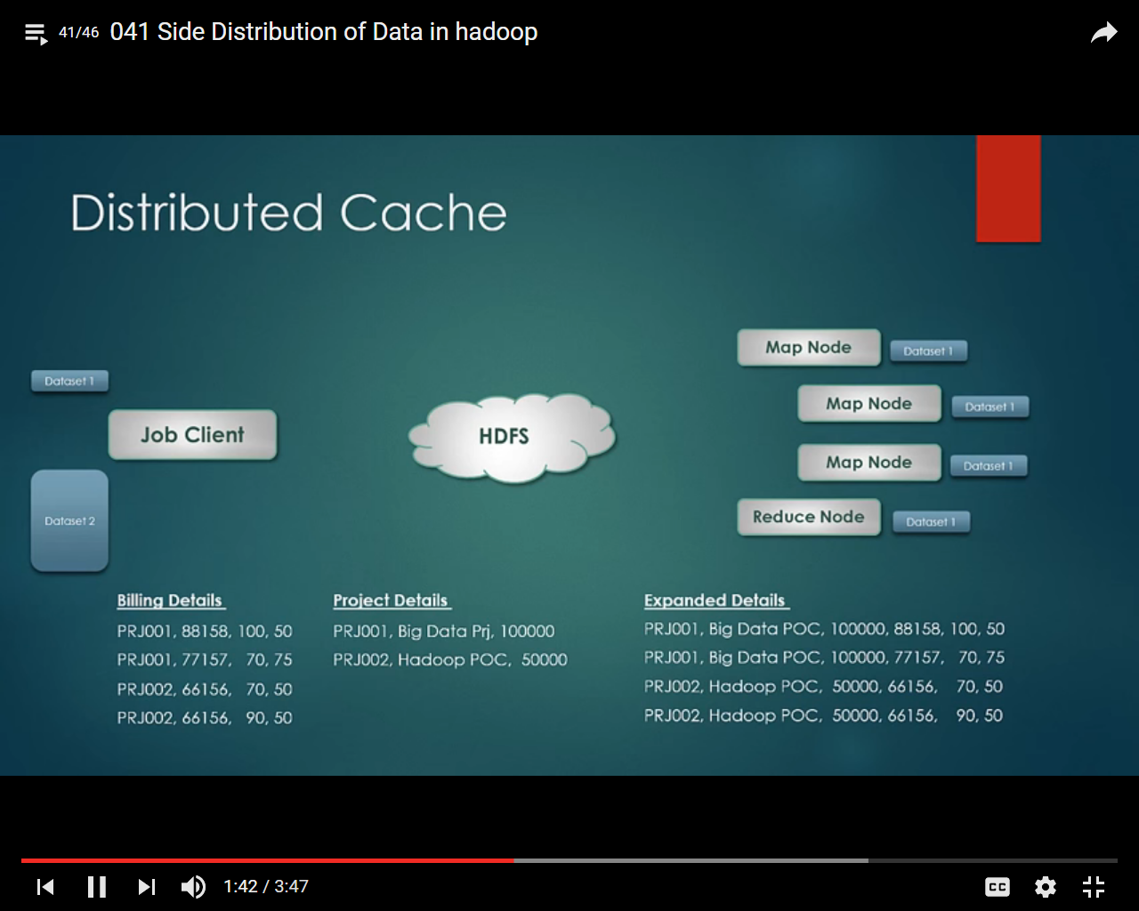

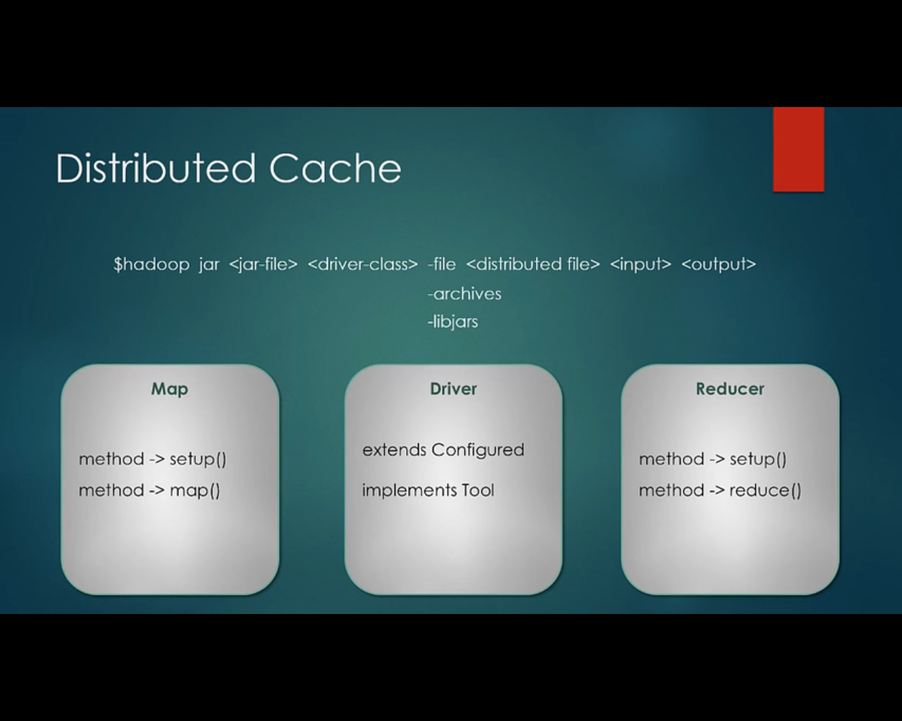

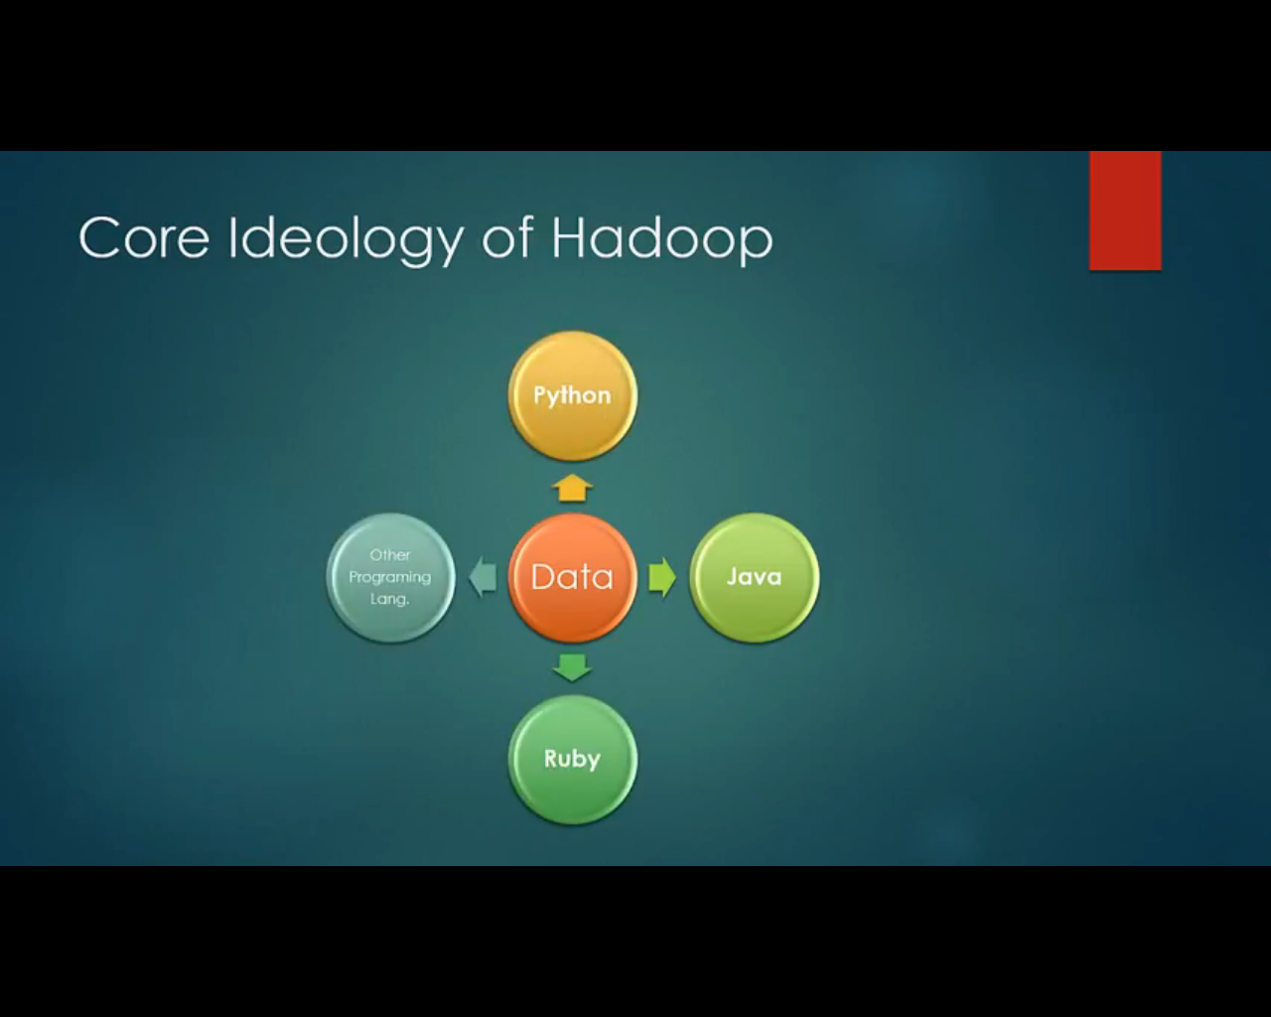

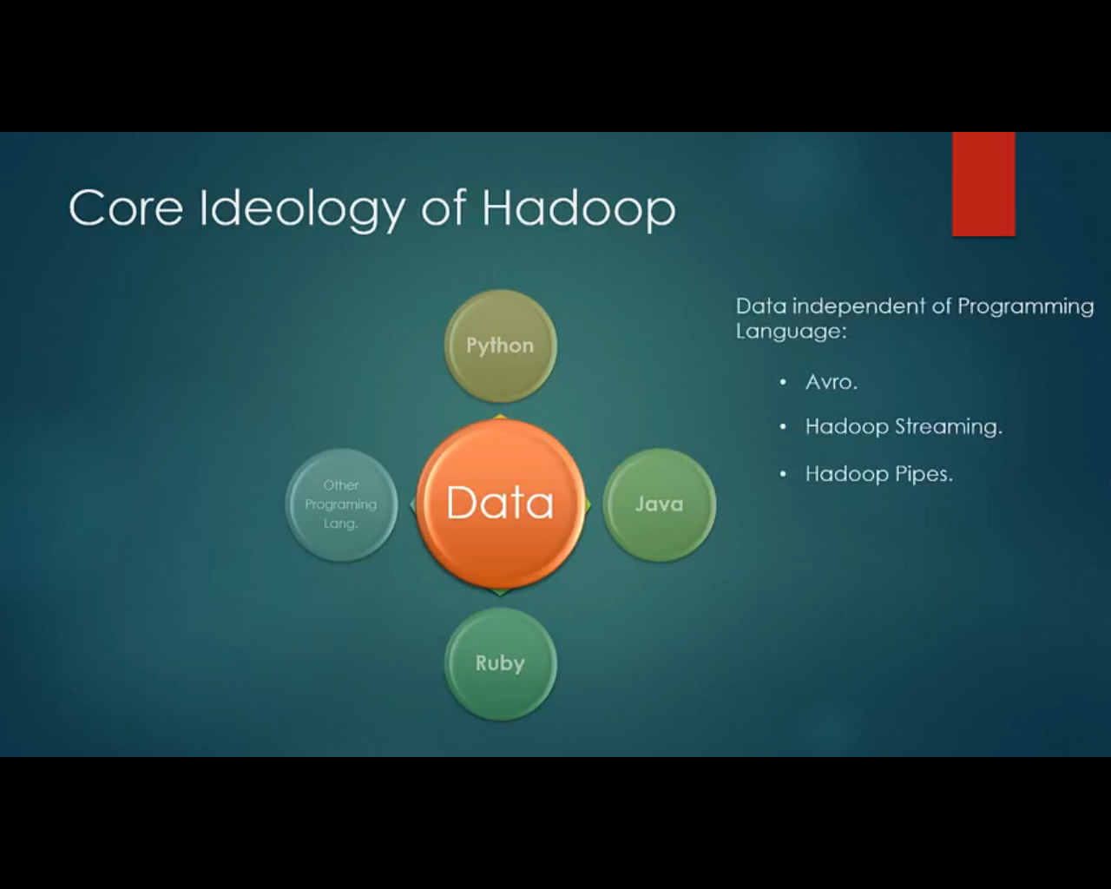

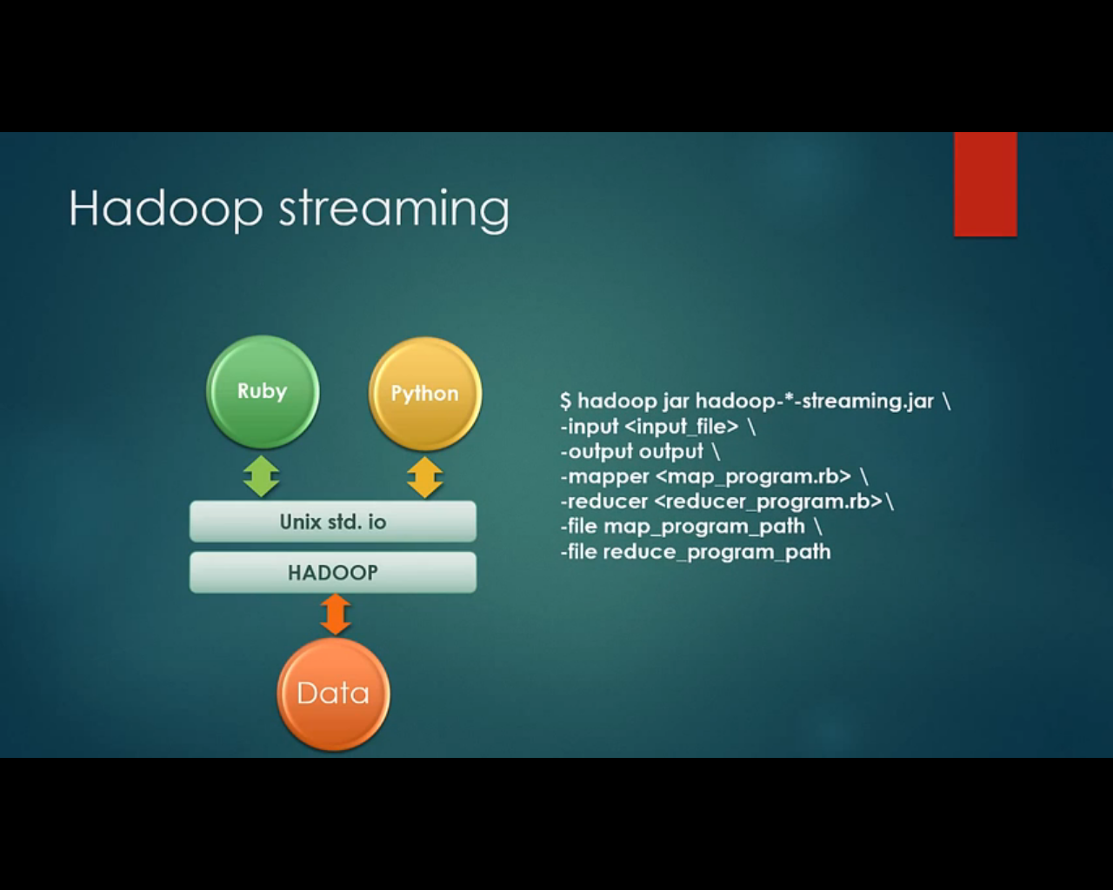

No driver class we need to provide two separate file for mapper and reducer which contains the logic, it could be a Ruby code, python code or simple shell command

